### Content: a path from Aalto University to University of Helsinki

* GPS locations along the path
* Street view photos

### The driving path: from Espoo to Helsinki

|  |  |  |
| --- | --- | --- |
|  |  |  |
| Espoo | --> | Helsinki |

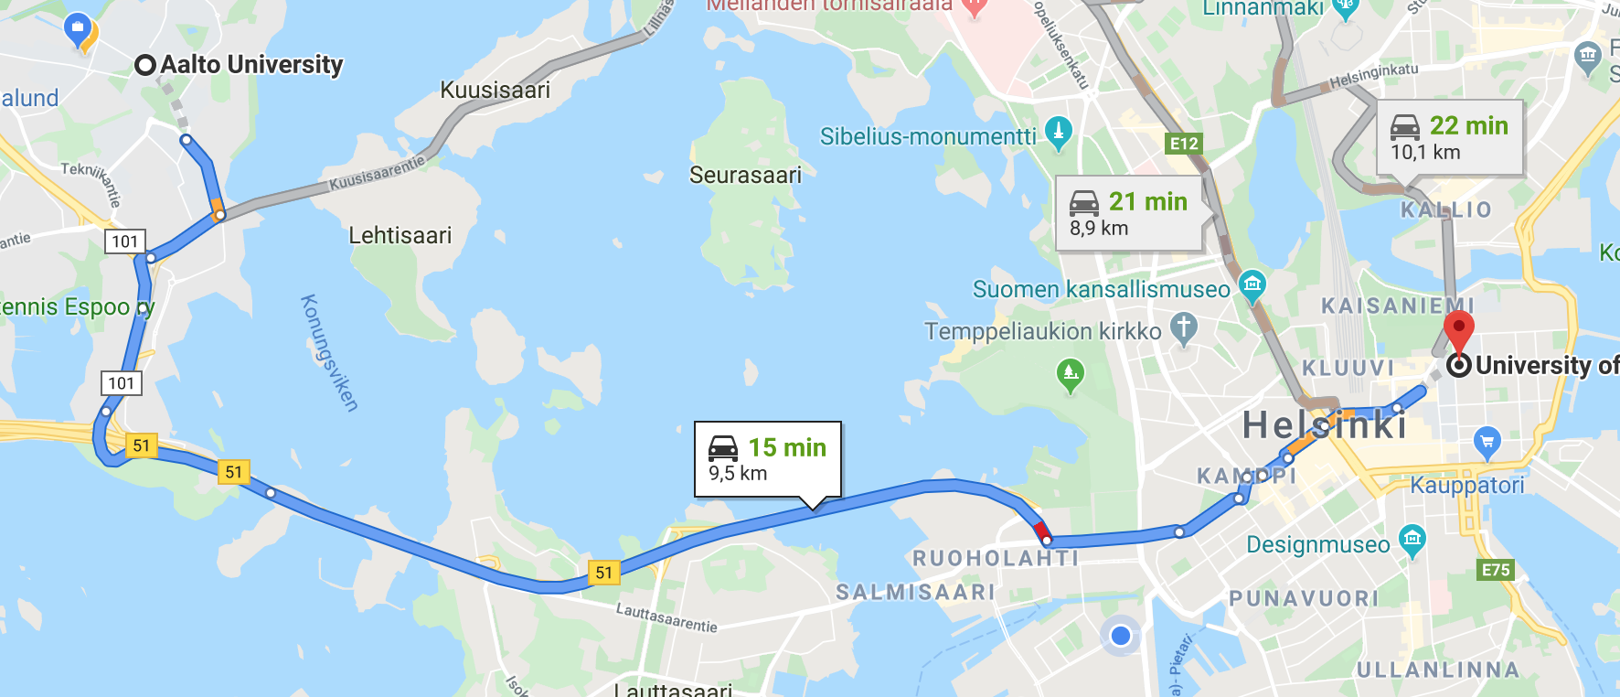

### 

### Files

trace.json: a list of coordinations representing the path in the json format

gsv_{i}.jpg: the photo taken from a specific coordination, “i” corresponds to the index in the path

regions.json: the corresponding region of each point in the path

{region}.json: the digital map of a region

### Trace points

|  |  |
| --- | --- |
| Coordination | Photo |
| 60.1837314,24.8303574 |  |
| 60.1839877,24.8285737 |  |
| 60.1830765,24.8272255 |  |
| 60.1819769,24.824864 |  |